- The minutes of March's Monetary Policy Committee meeting suggested we're getting closer to the first UK interest rate cut. We think a lack of new data will stop the MPC moving in May. But a June cut looks likely, provided that the pivotal April data for pay growth and core inflation eases concerns about inflation persistence.
- Shadow Chancellor Rachel Reeves used the Mais Lecture to confirm that a Labour administration would change the fiscal rules to provide more scope for public investment. But her vow to keep the current, deeply flawed, debt rule threatens to undermine a Labour government's ability to promote growth, and we think a more comprehensive overhaul would yield better outcomes.
The Monetary Policy Committee moved another step closer to cutting interest rates this week. At February's meeting, the MPC had removed its bias to tighten further, and March's meeting saw the two final holdouts – Catherine Mann and Jonathan Haskel – abandon their votes to hike and switch to voting with the majority for 'no change'. It's now a question of how long we must wait for four members to join lone dove Swati Dhingra in voting for a rate cut.
The minutes of March's meeting made clear that there's a wide range of views among the MPC on the extent of "inflation persistence" and how much more evidence they would need before voting for a cut. At face value, this week's inflation data backed the more hawkish interpretation, with services inflation of 6.1% being well above historical averages. But a decent chunk of that strength reflects last April's large increases for index-linked contracts and regulated prices, which baked in high inflation for those categories for the following 12 months. Looking at the three-month-on-three-month annualised rate offers a better guide to more recent trends, and this suggests momentum has been much softer in recent months (Chart 1).
Only one more set of pay and inflation data will be published before the May MPC meeting. We think a big downside surprise in at least one of these data releases would be needed to generate enough votes for a cut in May. So we continue to think a June cut is a much more likely prospect.
Chart 1: The momentum behind inflation has softened considerably in recent months
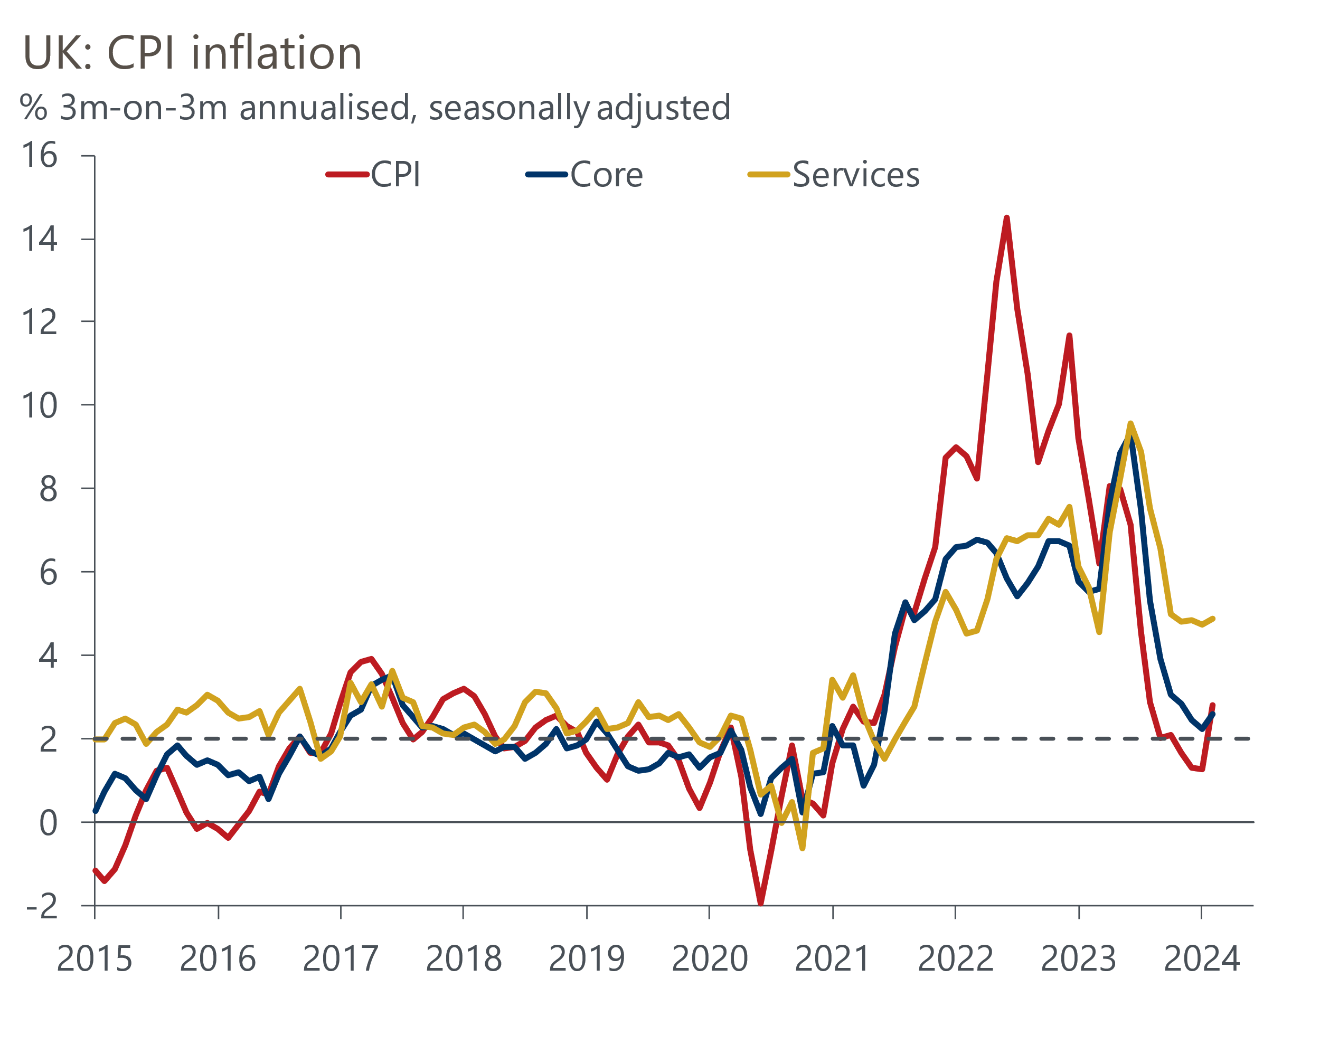
Source: Haver Analytics

Two further pay and inflation releases will be published between the May and June meetings, including the key April outturns for both. If this year's increases for index-linked contracts and regulated prices are much lower, as we expect, it will provide reassurance to members concerned about the stickiness of core inflation. Similarly, the MPC has cited April's near-10% rise in the national living wage as a potential source of upward pressure on wage growth. So if pay growth remains on a downward trajectory in April then this will also reduce concerns about the strength of second-round effects.
We continue to forecast two further 25bps rate cuts after June, lowering Bank Rate to 4.5% at the end of this year. But we still think the potential for inflation and pay growth to remain uncomfortably sticky means the risks are skewed towards the first cut coming later and the pace of rate cuts being slower. Indeed, that risk was highlighted by the flash S&P Global/CIPS survey for March, which reported the highest reading for selling prices since last July.
But the S&P Global/CIPS survey had better news on the activity front, with another solid reading for the composite PMI and signs that the manufacturing sector might be pulling out of its slump (Chart 2). Meanwhile retail sales were flat in February, and the strength of January's rebound was revised up. So prospects for a recovery in GDP in Q1, reversing most of the H2 2023 weakness, remain good.
Chart 2: Surveys suggest GDP will recover in Q1, despite the ongoing drag from public sector strikes
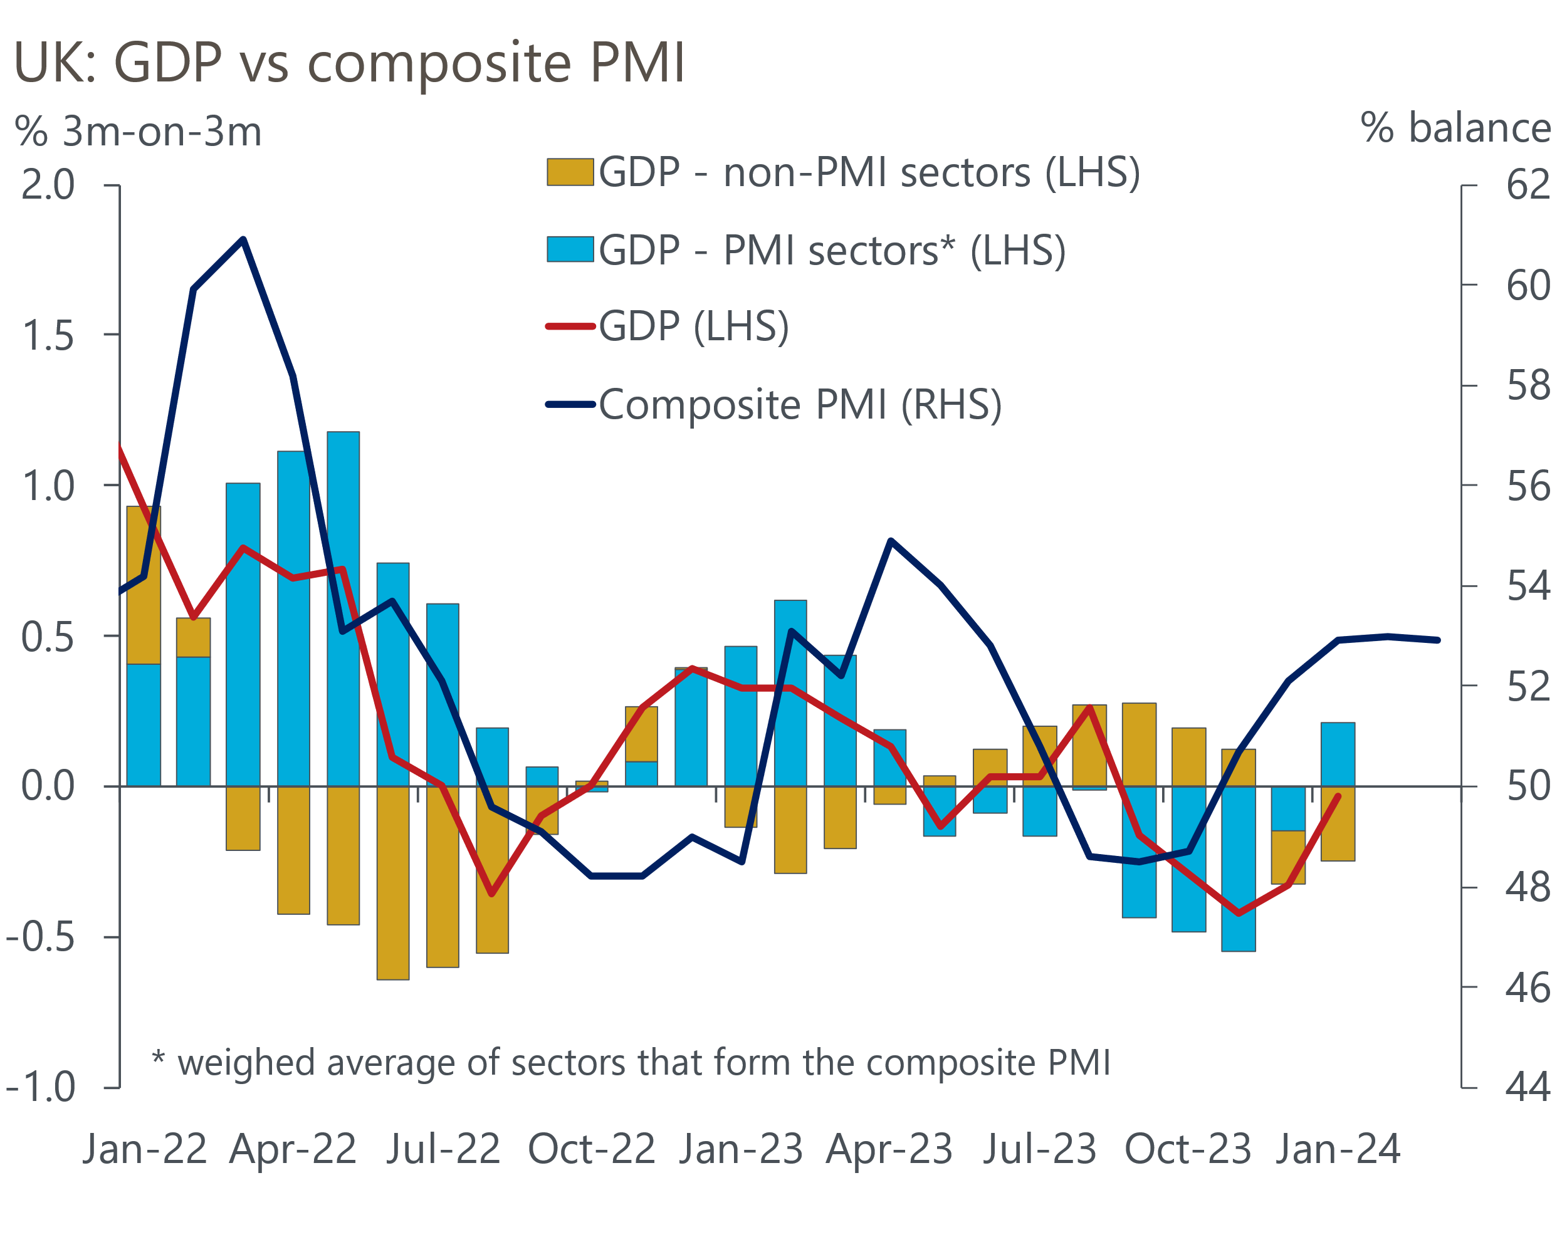
Sources: Oxford Economics/ONS/S&P Global/CIPS
While the monetary stance looks likely to be loosened in the coming months, developments on the fiscal front are likely to be a bigger influence on the outlook for economic growth over the next few years. Opinion polls suggest the governing Conservatives continue to haemorrhage support, with Labour consistently leading by 20ppts or more. So this week's Mais Lecture by Shadow Chancellor Rachel Reeves promised to give a good steer on how fiscal policy might evolve after the general election.
Reeves demonstrated that she understood some of the flaws in the current fiscal setup, correctly identifying very low levels of public investment as a major problem. To help to tackle this issue, she confirmed that a Labour administration would remove investment from the deficit rule by switching the target to achieving a balance on the current budget measure, i.e., tax revenues matching day-to-day spending.
But while that was a positive step, Reeves also confirmed that a Labour government would maintain the current, deeply flawed, debt rule. In its current form, the debt rule will be a more binding constraint on policy over the next decade than the deficit rule. So unless Labour has a change of heart before taking power, it risks repeating some of the mistakes of the current government by choosing fiscal rules that undermine its ability to stimulate growth via higher capital spending. As we demonstrated in our recent report, a more comprehensive overhaul of the fiscal rules could boost growth, lower the debt-to-GDP ratio, and reduce the scale of austerity that the next government will be forced into. So the rewards could be there for Labour, if it's prepared to be bolder in its reforms.

The week ahead
There's only one major ONS release and a smattering of business surveys due out next week. The Quarterly National Accounts for Q4 2023 will see the Office for National Statistics take its second stab at estimating GDP, with its initial estimate showing a surprisingly large contraction of 0.3% q/q. Given other data for the end of last year was consistent with a smaller drop in output, an upward revision would appear more likely than a downgrade.
The ONS will also publish its first estimates of household income growth and the savings ratio for Q4. In the absence of historical revisions, the fall in consumer spending in the final quarter of last year suggests there was probably another increase in the savings ratio, from its already-elevated level in Q3.
Table 1: Week ahead calendar
Date | Events | Period | Measure | Unit | Previous | Forecast
Mar 28 | GDP | Q4 | q/q | % | -0.3 | -0.3
Mar 28 | GDP | Q4 | y/y | % | -0.2 | -0.2
Mar 29 | UK Bank Holiday
Source: Oxford Economics

Key forecasts
Table 2: UK forecast overview
(Annual percentage changes unless specified)
 | 2022 | 2023 | 2024 | 2025 | 2026 | 2027
GDP | 4.3 | 0.1 | 0.5 | 2.0 | 2.0 | 1.6
Private consumption | 4.8 | 0.3 | 0.9 | 2.6 | 2.2 | 1.6
Fixed investment | 8.0 | 2.9 | -3.4 | 1.0 | 2.8 | 2.1
Government consumption | 2.3 | 0.6 | 3.9 | 2.3 | 1.5 | 1.5
Exports of goods and services | 9.0 | -1.4 | -1.0 | 2.8 | 2.4 | 1.7
Imports of goods and services | 14.6 | -1.6 | 1.2 | 3.5 | 2.9 | 1.9
Industrial Production | -3.5 | -0.3 | 0.0 | 0.9 | 1.5 | 1.2
Consumer prices | 9.1 | 7.3 | 2.2 | 2.1 | 2.3 | 2.2
Unemployment rate (%) | 3.9 | 4.0 | 4.0 | 3.9 | 3.8 | 3.7
Current a/c balance (% of GDP) | -3.1 | -2.8 | -2.9 | -2.9 | -3.0 | -2.9
Government balance (% of GDP) | 4.4 | 5.0 | 3.2 | 2.8 | 2.0 | 1.3
Cen. bank policy rate (%, EOP) | 3.50 | 5.25 | 4.50 | 3.50 | 2.50 | 2.00
10yr govt. bond yield (%, EOP) | 3.67 | 3.54 | 3.82 | 3.47 | 3.01 | 2.85
Exchange rate (US$ per £, EOP) | 1.20 | 1.27 | 1.27 | 1.29 | 1.32 | 1.35
Exchange rate (euro per £, EOP) | 1.13 | 1.15 | 1.17 | 1.16 | 1.15 | 1.15
Source: Oxford Economics
Table 3: Quarterly forecasts for the UK
 | 2024 |  |  |  | 2025
 | Q1 | Q2 | Q3 | Q4 | Q1 | Q2 | Q3 | Q4
GDP (% year) | -0.2 | 0.1 | 0.6 | 1.5 | 1.7 | 2.0 | 2.1 | 2.2
CPI inflation (% year) | 3.5 | 1.8 | 1.7 | 1.8 | 1.8 | 1.9 | 2.4 | 2.4
Bank Rate (%, EOP) | 5.25 | 5.00 | 4.75 | 4.50 | 4.25 | 4.00 | 3.75 | 3.50
10yr gilt yield (%, EOP) | 4.00 | 3.94 | 3.88 | 3.82 | 3.75 | 3.67 | 3.58 | 3.47
US$ per £ (EOP) | 1.28 | 1.27 | 1.27 | 1.27 | 1.28 | 1.28 | 1.28 | 1.29
Euro per £ (EOP) | 1.17 | 1.17 | 1.17 | 1.17 | 1.16 | 1.16 | 1.16 | 1.16
Source: Oxford Economics

Latest Country Economic Forecast:
March 18, 2024

Recent publications

Data Insights
February's retail data consolidates January's rebound
More evidence of growth, but also stickiness in inflation
The fiscal deficit continues to decline
Base effects drove a chunky fall in inflation in February
GDP looks to be on the road to recovery

Research Briefings
MPC remains on track for a June rate cut
MPC preview – Caution is the name of the game
Rethinking the UK’s fiscal rules is a key to unlock growth
Is 'immaculate disinflation' likely?
Hunt goes all-in on another NICS trim

Contacts

Oxford Economics' UK team
- Andrew Goodwin - Chief UK Economist - agoodwin@oxfordeconomics.com
- Edward Allenby - UK Economist - eallenby@oxfordeconomics.com

